- Pre-Test Checklist

Test Environment
- Location : CAR B

Test Contents

- Once only for each distinct type of equipment:
- Neuron buffer configuration (NodeUtil Node Menu option ‘B’)
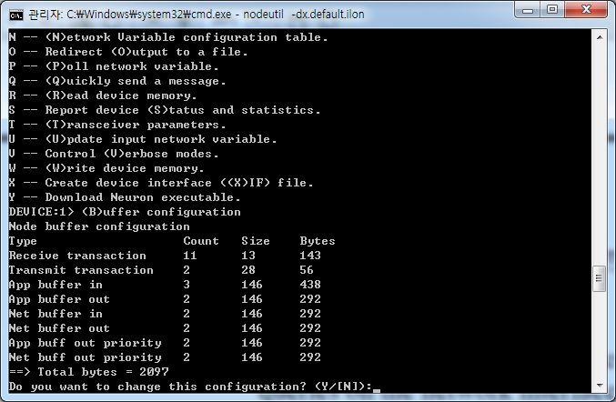

- ‘A’ network Setting
Domain Table (NodeUtil Node Menu option ‘D’)
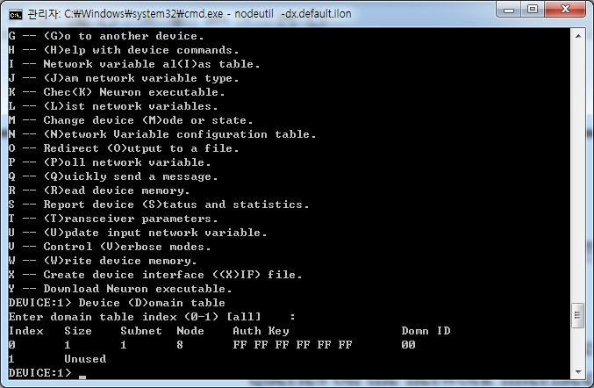

- Application Configuration Structures (NodeIUtil Node Menu option ‘C’)
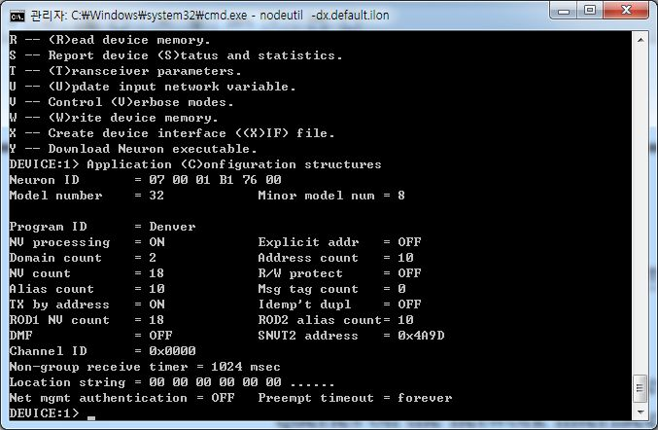

- Node Address Table (NodeUtil Node Menu option ‘A’)
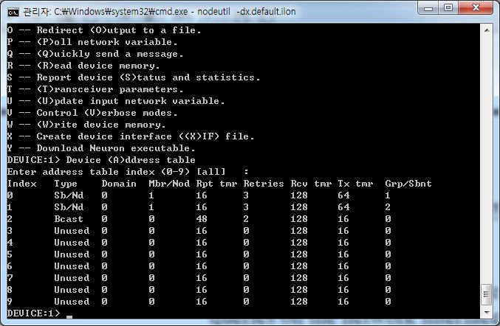
- List Network Variables (NodeUtil Node Menu option ‘L’)
Reading self-doc info...
#pragma set_id_string "Denver"
#pragma set_node_sd_string "COMM, WOOJIN, LIC, 2012-04-27"

#pragma app_buf_out_size 146
#pragma app_buf_out_count 2
#pragma app_buf_out_priority_count 2
#pragma net_buf_out_count 2
#pragma net_buf_out_priority_count 2
#pragma net_buf_in_size 146
#pragma net_buf_in_count 2
#pragma app_buf_in_size 146
#pragma app_buf_in_count 3
#pragma receive_trans_count 11

#pragma num_domain_entries 2
#pragma num_addr_table_entries 10
#pragma num_alias_table_entries 10

network input sd_string("&0,,0\x90,25;") config Non_SNVT var_0;
network input sd_string("@0|1") SNVT_obj_request var_1;
network output sd_string("@0|2") SNVT_obj_status var_2;
network input sd_string("@0|3") Non_SNVT var_3;
network output sd_string("@0|4") SNVT_time_stamp var_4;
network input sd_string("@0|5") SNVT_file_req var_5;
network output sd_string("@0|6") SNVT_file_status var_6;
network input sd_string("@1|1") Non_SNVT var_7;
network output sd_string("@1|2") SNVT_165 var_8;
network output sd_string("@1|3") SNVT_165 var_9;
network input sd_string("@1|4") bind_info( Unackd ) SNVT_state var_10;
network output sd_string("@1|5") Non_SNVT var_11;
network input sd_string("@1|6") bind_info( Unackd ) SNVT_165 var_12;
network input sd_string("@1|8") Non_SNVT var_13;
network input sd_string("@3|1") Non_SNVT var_14;
network output sd_string("@3|2") Non_SNVT var_15;
network input sd_string("@4|1") Non_SNVT var_16;
network output sd_string("@4|2") Non_SNVT var_17;
/*
-------------------------------------------------------------
Self documentation structure length = 186, version number = 0
Number of declared NVs = 18, total NVs = 18, message tags = 0
-------------------------------------------------------------
*/

- Network Variable Configuration Table (NodeUtil Node Menu option ‘N’)
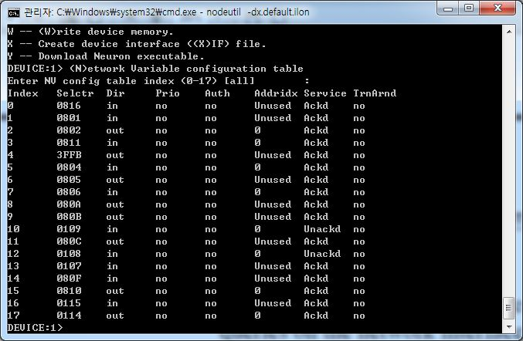

- ‘B’ network Setting
Domain Table (NodeUtil Node Menu option ‘D’)
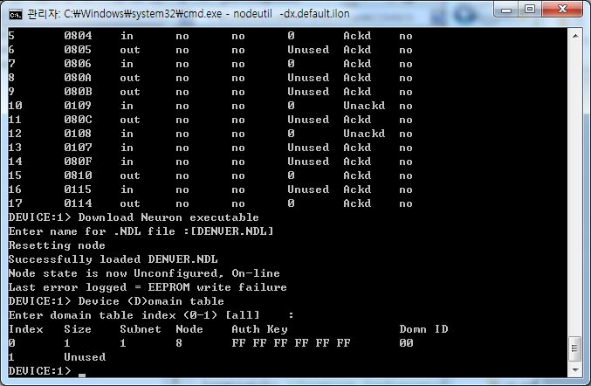

- Application Configuration Structures (NodeIUtil Node Menu option ‘C’)
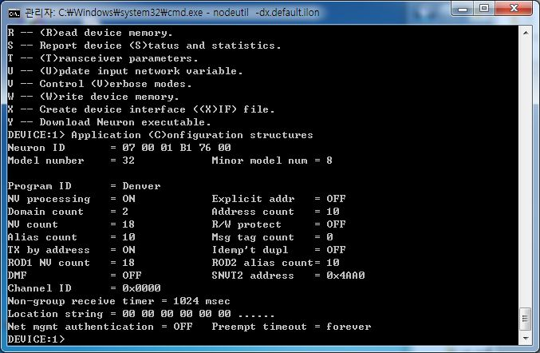

- Node Address Table (NodeUtil Node Menu option ‘A’)
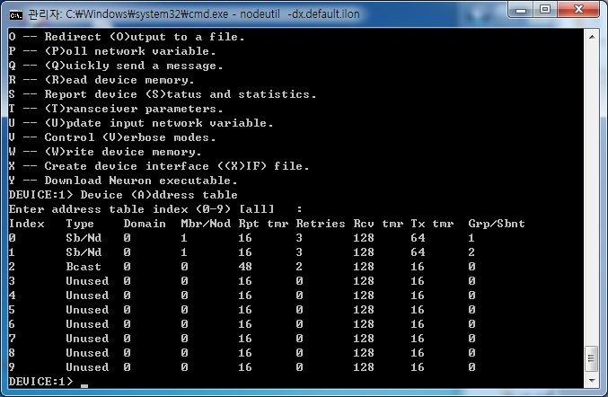

- List Network Variables (NodeUtil Node Menu option ‘L’)
Reading self-doc info...
#pragma set_id_string "Denver"
#pragma set_node_sd_string "COMM, WOOJIN, LIC, 2012-04-27"

#pragma app_buf_out_size 146
#pragma app_buf_out_count 2
#pragma app_buf_out_priority_count 2
#pragma net_buf_out_count 2
#pragma net_buf_out_priority_count 2
#pragma net_buf_in_size 146
#pragma net_buf_in_count 2
#pragma app_buf_in_size 146
#pragma app_buf_in_count 3
#pragma receive_trans_count 11

#pragma num_domain_entries 2
#pragma num_addr_table_entries 10
#pragma num_alias_table_entries 10

network input sd_string("&0,,0\x90,25;") config Non_SNVT var_0;
network input sd_string("@0|1") SNVT_obj_request var_1;
network output sd_string("@0|2") SNVT_obj_status var_2;
network input sd_string("@0|3") Non_SNVT var_3;
network output sd_string("@0|4") SNVT_time_stamp var_4;
network input sd_string("@0|5") SNVT_file_req var_5;
network output sd_string("@0|6") SNVT_file_status var_6;
network input sd_string("@1|1") Non_SNVT var_7;
network output sd_string("@1|2") SNVT_165 var_8;
network output sd_string("@1|3") SNVT_165 var_9;
network input sd_string("@1|4") bind_info( Unackd ) SNVT_state var_10;
network output sd_string("@1|5") Non_SNVT var_11;
network input sd_string("@1|6") bind_info( Unackd ) SNVT_165 var_12;
network input sd_string("@1|8") Non_SNVT var_13;
network input sd_string("@3|1") Non_SNVT var_14;
network output sd_string("@3|2") Non_SNVT var_15;
network input sd_string("@4|1") Non_SNVT var_16;
network output sd_string("@4|2") Non_SNVT var_17;
/*
-------------------------------------------------------------
Self documentation structure length = 186, version number = 0
Number of declared NVs = 18, total NVs = 18, message tags = 0
-------------------------------------------------------------
*/

- Network Variable Configuration Table (NodeUtil Node Menu option ‘N’)
